WIND POEM
Wind blowing through the trees
Wind playing in the leaves
Wind brushing agains the sky
Wind knocking over you and I

- ACTIVITY: Verbs in action
In the poem there are four verbs. Match the verb with the correct picture.
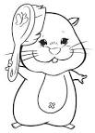

BLOWING

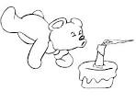

PLAYING

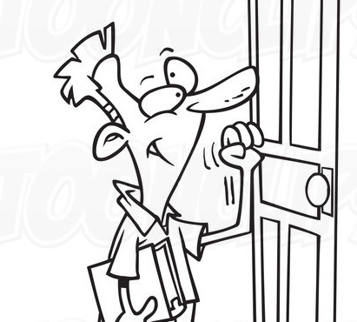

BRUSHING
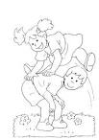

KNOCKING

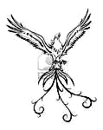
- ACTIVITY : Is it real or fantastic?

In the poem the wind is doing some actions that are not real. But if you are a poet you can write new strange connections between words and things.

* PLAY this game, CHOOSE the words!

WIND DANCING IN THE ….  SKY  WOOD  SEE

WIND PLAYING WITH A …  KITE  HONEY BEE  SAND

WIND JUMPING OVER MY ….  HAND  TIE  LAND

WIND HIDING BEHIND …  MY KNEE  HOOD  THE NIGHT

* WRITE your own poem in the cloud!

WIND

__________________________________

__________________________________

